Exponent Laws Math Project

Prepare a project, using one of the formats outlined below, that describes the exponent laws covered in class.

Here is the list of requirements and what needs to be communicated in your final product:
- A description of the exponent laws for multiplying and dividing powers with the same base
  - Provide an example of each and a detailed solution.
- A description of the power of a power law.
  - Provide an example and a detailed solution.
- A description of the negative and zero law of exponents
  - Provide an example and a detailed solution.
- Examples of each exponent law must be original (must not include examples from our class notes or examples found in the textbook).

You may choose one of the following formats:
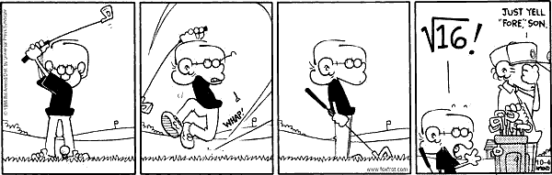
- Create a comic strip:

- The comic strip must contain:
- a minimum of 8 panels (the cartoon above contains only 4 panels)
- clearly drawn characters
- element(s) of humor, irony, drama, …

- Create a song:
- The song must contain:
  - 1 page of lyrics
  - 2 – 5 minute presentation (either live or recorded)
  - A parody of an existing song or an original work
  - A professional delivery (dramatic, humorous, …)

- Create a video:
- This video must contain:
  - A script
  - 2 – 5 minute presentation (either live or taped)
  - A parody of an existing tv/film production or an original work
  - A professional delivery (dramatic, humorous, informative, …)

- Create a skit:
- The skit must contain:
  - A script
  - Between 2 – 5 minutes of demonstration time
  - A physical model, prop, object, or product
  - A professional delivery (dramatic, humorous, informative, …)

- Create a brochure OR a poster:
- This must contain:
  - Images/pictures
  - A professional appearance

- Create a website OR a PowerPoint presentation:
- This must contain:
  - Images/pictures
  - A professional appearance

- Other
- This must be discussed with Ms. Sheerin and approved in advance.

You may choose to work alone or with a partner.

You will be evaluated on how complete and thorough your product is, the quality of your project, the use of your own words, the visual impact of your final product, and how well you communicate your knowledge. Please refer to the detailed scoring rubric below for the mark breakdown and to determine how you will be evaluated.

You will be given a limited time in class to work on this project, so if you choose to work with a partner, ensure that you will be able to communicate adequately and put the project together on your own time.

Here are some due dates:

Date for choosing a partner (if applicable) and a format: ___________________________
Due Date/Presentation Date: ___________________________
Cut-off Date: ___________________________

Exponent Laws Project Scoring Rubric

Report Component | Criteria | Score
Math Content | - The student provides a detailed description of the exponent laws for multiplying and dividing powers with the same base as well as the power of a power law, negative exponent and zero exponent law. | A=____/25
 | - The student has provided a thoughtful example of each exponent law and a clear and thorough solution for each. | A=____/25
 | - The examples of each exponent law are original. | A=____/5
 | - Student shows thorough understanding of the exponent laws with a high degree of effectiveness. | A=____/5
Communication | - Creative presentation of ideas | C=____/5
 | - Descriptions of the 5 exponent laws are in the students own words. | C=____/10
 | - Clear communication of ideas | C=____/10
 | - All required elements are present including additional elements that add to the project (e.g. many graphics are included and are all relevant to the material being presented, etc.). | C=____/10
 | - Spelling and grammar  - Neat, organized and professional presentation | C=____/5
A =____/60; C=____/40

